REQUEST FOR QUOTATION

From: Norwegian Refugee Council (NRC)
Kosti Office, Al-Andalus Area, Al Andalus Street, North of WFP, East from COR
E-mail: mohammed.alkhidir@nrc.no - abdalla.salih@nrc.no
Mobile: +24919938646 +249911736698

Date: 16/10/2022
No. of pages including this page: 5

Subject: Replacement of Water Transmission Pipeline in Alalagaia camp – White Nile State

PR Reference number: 8400141

Manner of Submission:

Please submit your quotation in accordance with the requirements detailed below by hand delivery to Norwegian Refugee Council Kosti Office, Al-Andalus Area, Al Andalus Street, North of WFP, and East from CORE OR send e-mail for above mentioned e-mails with subject RFQ-8400141 bidding

Deadline for submission of quotations is 20/10/2022 at 3:00 pm. Companies or suppliers who do not submit their quotation by this deadline will not be considered.

Requirements:
The office of the Norwegian Refugee Council invites your company to make a firm offer for the following items:

Ref # | Title | Item(s) Description | Unit | Quantity | UNIT Price | TOTAL Price
 | GENERAL INSTRUCTIONS | By populating and pricing the BOQ items below, the Tenderer certifies and confirms his complete acquaintance with and understanding of the Site Conditions, Work Scope, Designs, Specifications, BoQ ,the prevailing market conditions and the local laws and regulations. All and any other items not priced hereunder shall be deemed part of the Unit Rate Pricing. All works should be done according to the code of practice , Engineering Standards and the Instruction/ Satisfaction of NRC .
1.1 | Transmission pipe line | dismantle the damaged pipeline and Supply, erect and fix in position galvanized pipes 4" (6 meter lenght per each pipe) including all required fittings (adapter, flanges.... etc), rate shall include leackage testing, welding according to engineering specifications, engineer instructions and NRC satisfaction | ML | 78.00
1.2 | Support blocks | Supply materials, lay and build with Red bricks in 1:6 sand/cement mortar (50cm*50cm) after excavation until Reach fixed land , on different places under the galvanized pipe to put it in same elevation of the existing pipeline as per specifications and engineer instructions . | No | 6.00
 |  | TOTAL ( VAT EXCLUDED)
 |  | VAT (17%)
 |  | GRAND TOTAL ( VAT INCLUDED)

Picture From Work Site

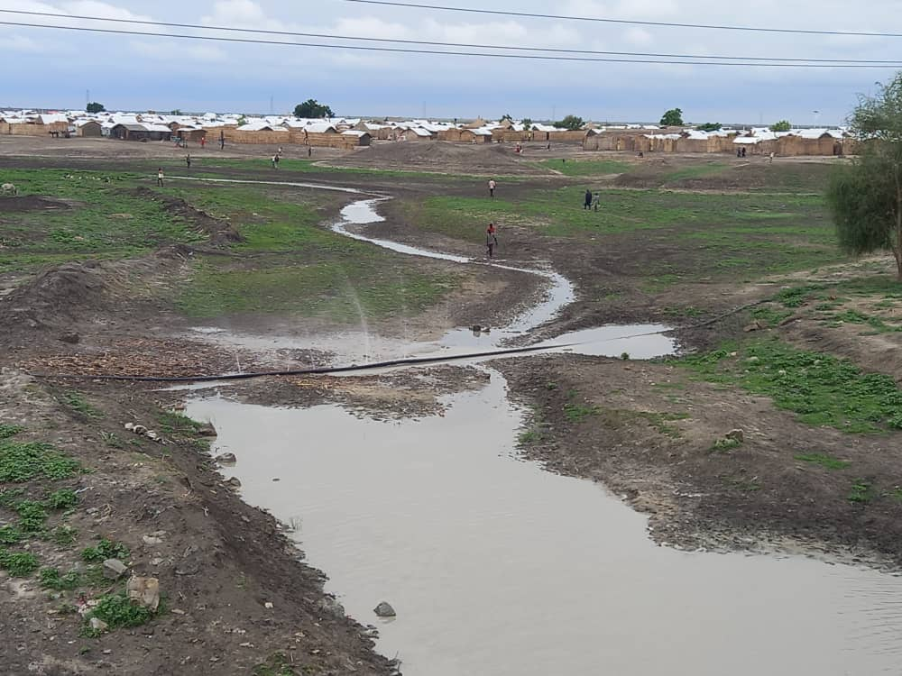

Important Notice:

- NRC strongly advice contractor/supplier to visit construction before bidding and don’t relay only on attached picture.
- The location: Alalagaia camp – Eljabalain locality – White Nile State.
- Latitude: 12.3683679 Longitude: 32.8030305
- You can use the above table or print your quotation on your own letterhead documents.
- If different taxes & fees apply, please specify them all in your quotation.

2 - PLEASE ANSWER THE QUESTIONS:

Questions | Answers
What is the currency of the offer?
(SDG, Euro, USD, other…)
Note that NRC will favour quotes in USD.

Do you accept payment after delivery?
(if not, please explain your payment terms)
Payment will be within 15 working days after the delivery of products

What is the validity period of your offer?
(in days)
(Preferable 30 days)

What is the completion time for this activity?

What is the guaranty period? (Preferable 3 months)

3 - ACCEPTED METHODS FOR SUBMISSION OF QUOTATION / OFFER:

- We recommend you fill up this Request for Quotation directly on your computer.
- You can also print it and fill it up by hand if you have not access to a computer.
- You can submit the price offer by using the table on page 1, or by using your own proforma document.
- Hand delivery to NRC office mentioned above on the first page or focal points e-mail.
- Your quotation / offer must be signed and stamped on all pages (including the present Request for Quotation).

4 - YOUR COMPANY DETAILS:

Name of the company

Name of the owner(s)
Date of birth of the owner(s)
(mandatory for screening)
اسم المالك
Address of the company

Name of contact person
شخص يمكن الاتصال به

Position الوظيفة

Email البريد الالكتروني

Phone
الهاتف

5 - MANDATORY DOCUMENTS TO ATTACH TO YOUR QUOTATION / OFFER:

Please check that you are providing all of the below mentioned documents:
Mandatory documents | Checked (Y/N)
Company registration certificate
Company tax registration certificate
NRC Request for Quotation (filled up, signed and stamped)
Additional quotation on company letterhead document, if any…
Suppliers Ethical Standards Declaration signed and stamped
Company profile stating implemented projects and relevant projects
Work schedule for project execution

You shall also attach additional documents such as photos, certifications of completions for relevant projects.

6 - PAYMENT INFORMATION:

Payment will be made within 30 days of receipt of goods / services, by bank transfer/cheque only.

NRC is not subject to VAT; therefore, all offers should be exclusive of VAT costs.

All suppliers doing business with NRC should maintain high standards on ethical issues, respect and apply basic human and social rights, ensure non-exploitation of child labour, and give fair working conditions to their staff. NRC reserves the right to reject quotations provided by suppliers not meeting these standards.
Vendors doing business with NRC will be screened on anti-corruption due diligence before NRC confirms an order or contract.

NRC aims to purchase products and services that the minimum environmental impact. Environmental considerations form part of the NRC selection criteria, and NRC reserves the right to reject quotations provided by suppliers not meeting these standards.

7 - INSPECTION

NRC is obliged to ensure that its procurement decisions are clearly justified, documented, and keeping within the Donors mandatory principles. In that regard, full and on-the-spot access must be granted to representatives of NRC, the Donor or any organisation or person mandated by it, to premises belonging to NRC or its contractors. The right to access shall include all documents and information necessary to assess, or audit the implementation of the contract

8 - OTHER INFORMATION:

Payment will be made by bank transfer/cheque only. يتم الدفع عبر التحويل البنكي او الشيك

All suppliers doing business with NRC should maintain high standards on ethical issues, respect and apply basic human and social rights, ensure non-exploitation of child labour, and give fair working conditions to their staff. NRC reserves the right to reject quotations provided by suppliers not meeting these standards.

Vendors doing business with NRC will be screened on anti-corruption due diligence before NRC confirms an order or contract.

NRC aims to purchase products and services that the minimum environmental impact. Environmental considerations form part of the NRC selection criteria, and NRC reserves the right to reject quotations provided by suppliers not meeting these standards.

NRC is obliged to ensure that its procurement decisions are clearly justified, documented, and keeping within the Donors mandatory principles. In that regard, full and on-the-spot access must be granted to representatives of NRC, the Donor or any organisation or person mandated by it, to premises belonging to NRC or its contractors. The right to access shall include all documents and information necessary to assess, or audit the implementation of the contract

NRC reserves the right to accept or reject the whole or part of your quotation based on the information provided. Incomplete quotations, which do not comply with our conditions, will not be considered.

Shortlisted suppliers may be required to submit samples of each item. Please be sure to have all samples available at short notice, and wait for a response from NRC if you have been shortlisted.

